Major Project Report
On
“CAGE : Material CSS Framework”
Submitted in partial fulfilment of the requirement for the award of the degree of
Bachelor of Computer Applications
submitted by
ANUBHAV KUMAR
SAKSHAM LUTHRA
BCA 6th Semester
Under the supervision of
Mr. Harjender Singh
Assistant Professor
Department of Computer Science


MAHARAJA SURAJMAL INSTITUTE
Department of Computer Science
C-4, Janakpuri, New Delhi – 100058

MAHARAJA SURAJMAL INSTITUTE

BONAFIDE CERTIFICATE

Certified that this project report “CAGE: a dark CSS Library”
is the bonafide work of “Anubhav Kumar and Saksham Luthra” who carried out the project work under my supervision.

Mr. Harjender Singh
SUPERVISOR
Assistant Professor Department of Computer Applications

Acknowledgement

I would like to express my gratitude to my mentor Mr. Harjender Singh who motivated me to work on this project. He constantly supported me and gave advices to efficiently work on this project.

Also, I would like to thank the college staff, classmates and my parents who provided motivation and Inspiration to take up this project and put all my efforts into it.

Anubhav Kumar, 00421202016
Saksham Luthra, 03721202016

TABLE OF CONTENTS

- Introduction
1.1 Objective
1.2 Real World Scenario
1.3 Why Cage..?
1.4 Structure

- Components and Utilities
  - Components along Preview
  - HTML Element Code
  - Extras

- Responsive Design and Grid System
  - CSS Grid along Screenshots
  - Table Grids
  - Grid Code

- Tools Used
  - HTML
  - CSS
  - SASS, JAVASCRIPT, etc.

5. Road to the Result
  - How are we going to achieve the result
  - Screenshots
  - Fractions (+code)
  - Mixin Functions (+code)
  - Color Schemes
  - Slate.scss
6. How to use cage..?

7. Conclusion
8. References

Cage – The Materialized Dark CSS Framework

- Objective
Developing a pre-defined library for styling and creating an elegant
and materialized website with minimum efforts. Unlike other frameworks
like Bootstrap, MDB etc. which creates a complex environment to work
upon, this will be a lightweight yet powerful framework to create your
desired design easily.

"CAGE FRAMEWORK" is a pre-defined CSS library/framework consisting of number of classes and components which are defined in a manner that makes it very easy for even a beginner who just know a little of html to design a full front-side website according to their imagination.

In this framework we are going to use CSS—grid and flexbox which makes the alignment of elements easier which previously done by float and margins, but now without its use we can achieve better results that makes the code less clumsy and easy to understand also it provides little responsiveness to the website without even deﬁning the media queries but we are going define media queries to make any website design with this framework responsive which means it fits itself according to the width and height of the viewport.

It is a Web Development categorized project which focuses on the simple designs of the websites to be developed and also the main focus will be on the dark themes only.

It means that all the elements and codes in this CSS framework is intended to the development of websites that are having dark background and themes.


Real World Scenario

In real world, not every developer is fond of styling the complete website from scratch, so they prefer to use pre-defined libraries which offers them to design their website by just using class or id names to their element and start working on the functionality without wasting any time on designing.

WHY CAGE..?

In the market these days there are a handful of CSS Frameworks available which provide the same usage as we are. But, the main issues with them are that either they are too complex to implement or heavy weighted or both.
Also, not every framework is providing material design to the user.

STRUCTURE :

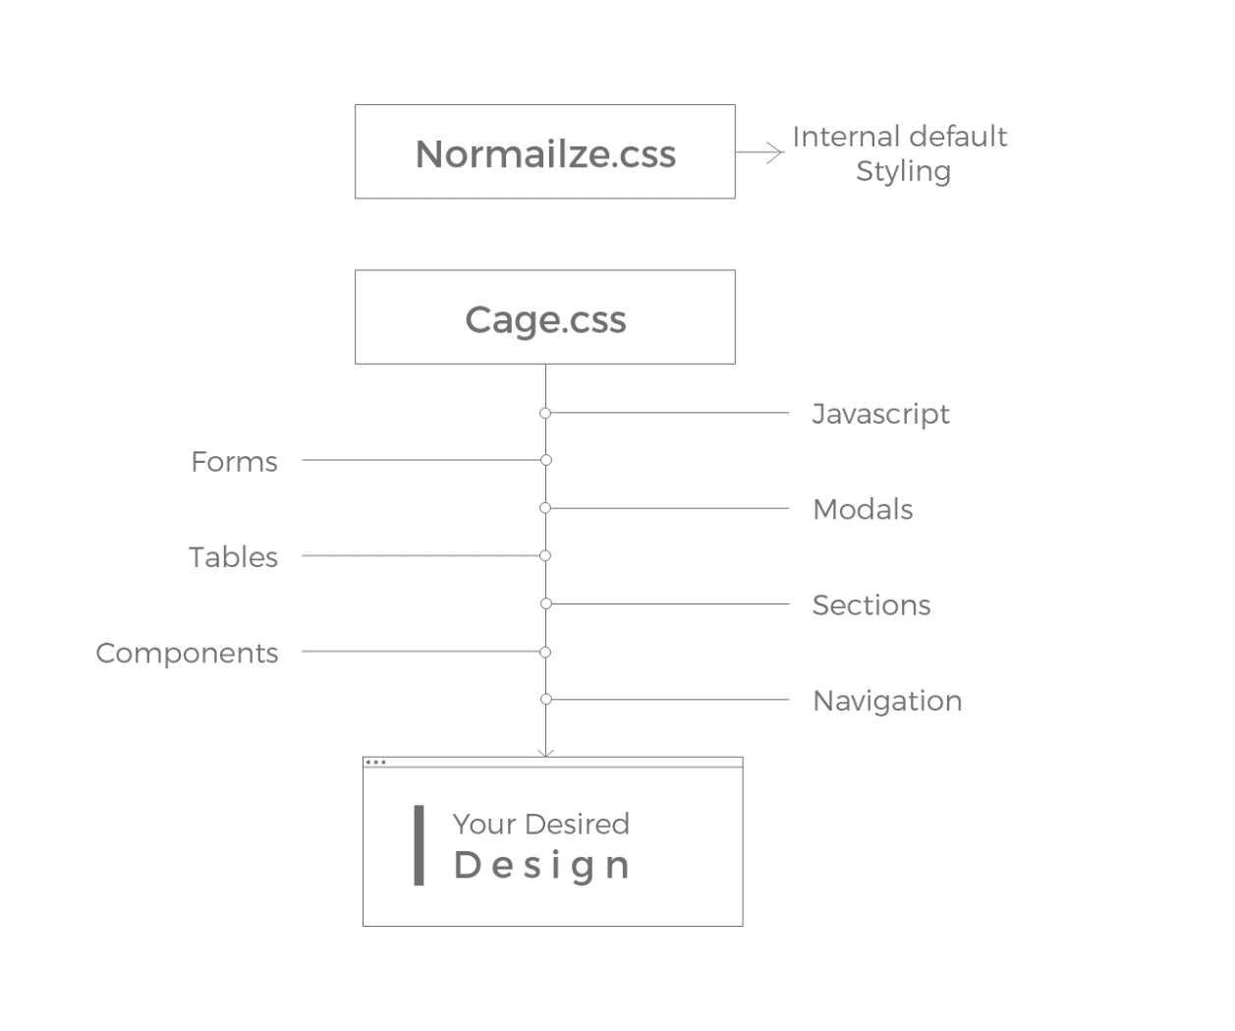
With Cage framework the user can experience the following:
- Light Weight
- Easy to implement
- Materialized Design
- Responsiveness
- And other loads of customization...

Cage contains simple design UI components which helps the user to fastly create an element and give a design to it. The element designs are muted, light weight, and are easy to implement. Unlike Bootstrap, Materialize, it doesn’t have much of functionality and multiple high frame components, but whatever the small cage has is super simple and is great.

So, pack your bags and get on board to enjoy the journey of a dark library…

Components and Utilities

- Accordion

Accordions are useful when you want to toggle between hiding and showing large amount of content.
An accordion is used to show (and hide) HTML content.
It is a component which organizes content within collapsable items. Accordion allows
showing only one collapsed item at the same time.
Accordions can toggle through a number of text blocks with a single click, and that
greatly increases the UX of your project.

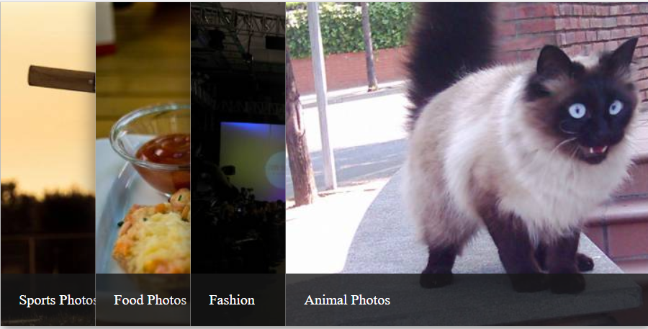

Code: (HTML)
<link rel="stylesheet" href="style.css">
<div class="slider">
<ul>
<li>
<div class="title"><a href="#">Sports Photos</a></div>
<img src="http://lorempixel.com/600/360/sports" />
</li>
<li>
<div class="title"><a href="#">Food Photos</a></div>
<img src="http://lorempixel.com/600/360/food" />
</li>
<li>
<div class="title"><a href="#">Fashion</a></div>
<img src="http://lorempixel.com/600/360/fashion" />

</li>
<li>
<div class="title"><a href="#">Animal Photos</a></div>
<img src="http://lorempixel.com/600/360/animals" />
</li>
</ul>
</div>

- Alert

Alerts are feedback messages that are displayed after specific actions performed by the user. The length of the text is unlimited.
With the right use of colors, they add some emotional weight to our information, ranging from a simple warning to a critical system failure or from an operation successful message to a piece of neutral information.

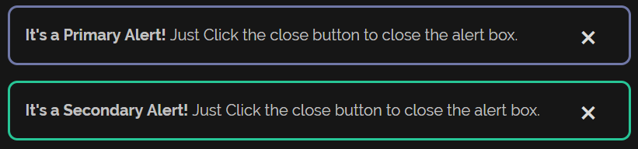

Code: (HTML)
<div class="mt-3 alert primary-alert" role="alert">
<strong>It's a Primary Alert!</strong> Just Click the close button to close the alert box.
<button type="button" class="close" aria-label="Close">
<span aria-hidden="true">&times;</span>
</button>
</div>

<div class="mt-3 alert secondary-alert" role="alert">
<strong>It's a Secondary Alert!</strong> Just Click the close button to close the alert box.
<button type="button" class="close" aria-label="Close">
<span aria-hidden="true">&times;</span>
</button>
</div>

- Buttons

Users can use the Cage’s custom designed material and minimal button styles for actions in forms, dialogs and more with custom themed buttons.
There's hardly any website which doesn't have at least one button. That's why having decently styled buttons is vital if you want to be a successful web designer.



Code: (HTML)
<button class="btn btn-primary">button 1</button>
<button class="btn btn-secondary">button 2</button>

- Cards

Cards are components which display content built of different elements with characteristic shadows, depth and hover effects.
It is hard to think of a better way of displaying your content to users other than by using cards. Some of the biggest players like Facebook or Google are well aware of that, as you might have noticed in almost all their products.
Cards provide you with clarity, clean content categorization and an attractive way of presenting it to your users.

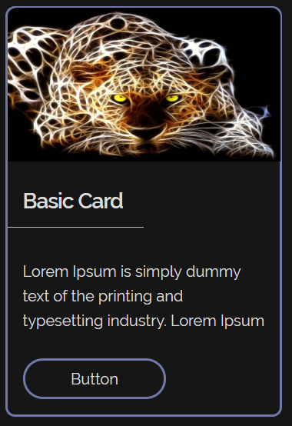

Code: (HTML)
<div class="mt-3 card primary-card">
<div>
<img class="card-img" src="https://i.pinimg.com/originals/5a/e5/8f/5ae58f5036997cfd4636917403c3c951.jpg" alt="">
</div>
<div>
<h5 class="card-head">Basic Card</h5>
<hr class="cr-hr">
</div>
<div>
<p class="card-data">Lorem Ipsum is simply dummy text of the printing and typesetting industry. Lorem Ipsum</p>
</div>
<a class="card-btn btn btn-primary" href="javascript:void(0)">Button</a>
</div>

- Carousel Slider

The carousel is a slideshow for cycling through a series of content, built with CSS 3D transforms and a bit of JavaScript. It works with a series of images, text, or custom markup. It also includes support for previous/next controls and indicators.

A slideshow component for cycling through elements—images or slides of text—like a carousel.



Code: (HTML)
<div>
<div class="carousel">
<ul class="slides">
<input type="radio" name="radio-buttons" id="img-1" checked />
<li class="slide-container">
<div class="slide-image">
<img src="http://lorempixel.com/600/360/sports">
</div>
<div class="carousel-controls">
<label for="img-3" class="prev-slide">
<span>&lsaquo;</span>
</label>
<label for="img-2" class="next-slide">
<span>&rsaquo;</span>
</label>
</div>
</li>
<input type="radio" name="radio-buttons" id="img-2" />
<li class="slide-container">
<div class="slide-image">
<img src="http://lorempixel.com/600/360/food">
</div>
<div class="carousel-controls">
<label for="img-1" class="prev-slide">
<span>&lsaquo;</span>
</label>
<label for="img-3" class="next-slide">
<span>&rsaquo;</span>
</label>
</div>
</li>
<input type="radio" name="radio-buttons" id="img-3" />
<li class="slide-container">
<div class="slide-image">
<img src="http://lorempixel.com/600/360/fashion">
</div>
<div class="carousel-controls">
<label for="img-2" class="prev-slide">
<span>&lsaquo;</span>
</label>
<label for="img-1" class="next-slide">
<span>&rsaquo;</span>
</label>
</div>
</li>
<div class="carousel-dots">
<label for="img-1" class="carousel-dot" id="img-dot-1"></label>
<label for="img-2" class="carousel-dot" id="img-dot-2"></label>
<label for="img-3" class="carousel-dot" id="img-dot-3"></label>
</div>
</ul>
</div>
</div>

- Checkbox

The checkbox is a component used to allow a user to make multiple choices which is broadly used in forms and surveys.

Checkboxes are used to select one or several options in a list, while radio (option) buttons are for selecting one option from many.

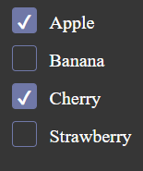

Code: (HTML)

<form>
<input type="checkbox" id="fruit1" name="fruit-1" value="Apple">
<label for="fruit1">Apple</label>
<input type="checkbox" id="fruit2" name="fruit-2" value="Banana">
<label for="fruit2">Banana</label>
<input type="checkbox" id="fruit3" name="fruit-3" value="Cherry">
<label for="fruit3">Cherry</label>
<input type="checkbox" id="fruit4" name="fruit-4" value="Strawberry">
<label for="fruit4">Strawberry</label>
</form>

- Collapsible

Toggle the visibility of content across your project with a few classes and our JavaScript.
The collapse JavaScript plugin is used to show and hide content. Buttons or anchors are used as triggers that are mapped to specific elements you toggle.
Collapsibles are useful when you want to hide and show large amount of content

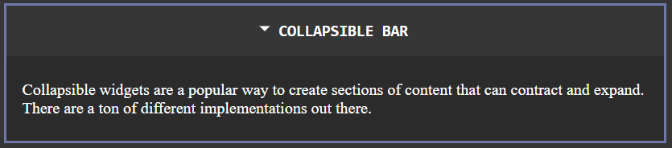

Code: (HTML)

<div class="wrap-collabsible">
<input id="collapsible" class="toggle" type="checkbox">
<label for="collapsible" class="lbl-toggle">Collapsible Bar</label>
<div class="collapsible-content">
<div class="content-inner">
<p>
Collapsible widgets are a popular way to create sections of content that can contract and expand.
There are a ton of different implementations out there.
</p>
</div>
</div>
</div>

- Dropdown

Toggle contextual overlays for displaying lists of links and more with the Cage dropdown plugin.
Dropdowns are toggleable, contextual overlays for displaying lists of links and more. They’re made interactive with the included cage dropdown CSS custom design without any javascript. They’re toggled by clicking, not by hovering; this is an intentional design decision.
No javascript means less heavy….-> lightweight

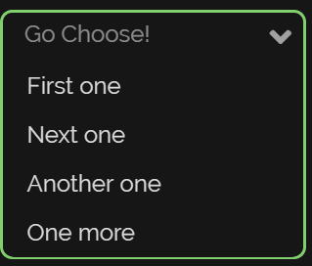

Code: (HTML)
<form class="dropdown mt-3">

<ul class="select">
<li>
<input class="select_close" type="radio" name="awesomeness" id="awesomeness-close" value=""/>
<span class="select_label select_label-placeholder">Go Choose!</span>
</li>

<li class="select_items">
<input class="select_expand" type="radio" name="awesomeness" id="awesomeness-opener"/>
<label class="select_closeLabel" for="awesomeness-close"></label>

<ul class="select_options">
<li class="select_option">
<input class="select_input" type="radio" name="awesomeness" id="awesomeness-ridiculous"/>
<label class="select_label" for="awesomeness-ridiculous">First one</label>
</li>

<li class="select_option">
<input class="select_input" type="radio" name="awesomeness" id="awesomeness-reasonable"/>
<label class="select_label" for="awesomeness-reasonable">Next one</label>
</li>

<li class="select_option">
<input class="select_input" type="radio" name="awesomeness" id="awesomeness-lacking"/>
<label class="select_label" for="awesomeness-lacking">Another one</label>
</li>

<li class="select_option">
<input class="select_input" type="radio" name="awesomeness" id="awesomeness-awesomeless"/>
<label class="select_label" for="awesomeness-awesomeless">One more</label>
</li>
</ul>

<label class="select_expandLabel" for="awesomeness-opener"></label>
</li>
</ul>

</form>

- Footer

Footer is an additional navigation for the website. It can hold links, buttons, company info, copyrights, forms and many other elements.

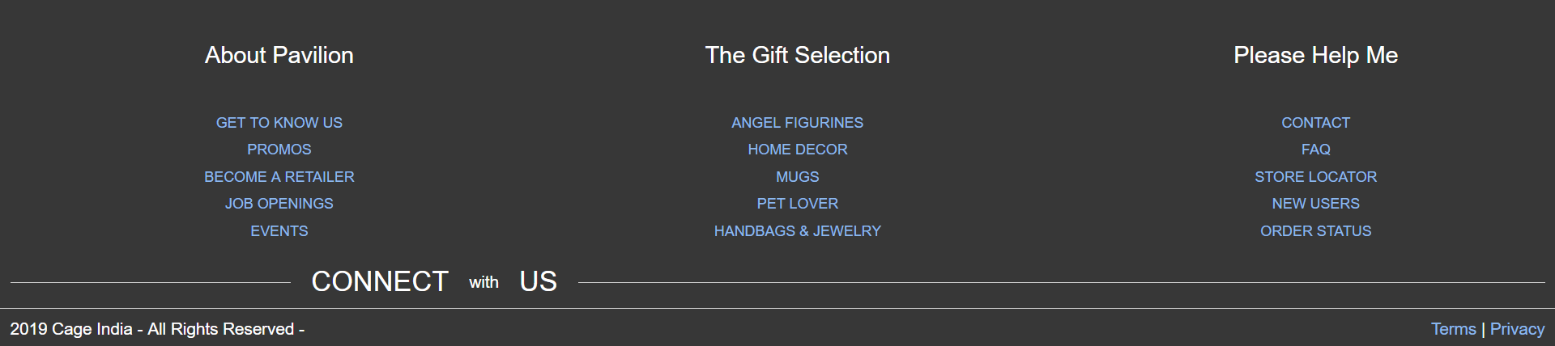

Code: (HTML)
<footer class="flex-rw">

<ul class="footer-list-top">
<li>
<h4 class="footer-list-header">About Pavilion</h4></li>
<li><a href='/shop/about-mission' class="generic-anchor footer-list-anchor" itemprop="significantLink">GET TO KNOW US</a></li>
<li><a href='/promos.html' class="generic-anchor footer-list-anchor" itemprop="significantLink">PROMOS</a></li>
<li><a href='/retailers/new-retailers.html' class="generic-anchor footer-list-anchor" itemprop="significantLink">BECOME A RETAILER</a></li>

<li><a href='/job-openings.html' itemprop="significantLink" class="generic-anchor footer-list-anchor">JOB OPENINGS</a></li>

<li><a href='/shop/about-show-schedule' class="generic-anchor footer-list-anchor" itemprop="significantLink">EVENTS</a></li>
</ul>
<ul class="footer-list-top">
<li>
<h4 class="footer-list-header">The Gift Selection</h4></li>

<li><a href='/Angels/cat/id/70' class="generic-anchor footer-list-anchor">ANGEL FIGURINES</a></li>
<li><a href='/Home-Decor/cat/id/64' class="generic-anchor footer-list-anchor">HOME DECOR</a></li>
<li><a href='/Mugs/cat/id/32' class="generic-anchor footer-list-anchor">MUGS</a></li>
<li><a href='/Pet-Lover/cat/id/108' class="generic-anchor footer-list-anchor">PET LOVER</a></li>
<li><a href='/Ladies-Accessories/cat/id/117' class="generic-anchor footer-list-anchor" target="_blank">HANDBAGS & JEWELRY</a></li>
</ul>
<ul class="footer-list-top">
<li id='help'>
<h4 class="footer-list-header">Please Help Me</h4></li>
<li><a href='/shop/about-contact' class="generic-anchor footer-list-anchor" itemprop="significantLink">CONTACT</a></li>
<li><a href='/faq.html' class="generic-anchor footer-list-anchor" itemprop="significantLink">FAQ</a></li>
<li id='find-a-store'><a href='/shop/store-locator' class="generic-anchor footer-list-anchor" itemprop="significantLink">STORE LOCATOR</a></li>
<li id='user-registration'><a href='/shop/user-registration?URL=' class="generic-anchor footer-list-anchor" itemprop="significantLink">NEW USERS</a></li>
<li id='order-tracking'><a href='/shop/order-status' itemprop="significantLink" class="generic-anchor footer-list-anchor">ORDER STATUS</a></li>
</ul>
<section class="footer-social-section flex-rw">
<span class="footer-social-overlap footer-social-connect">
CONNECT <span class="footer-social-small">with</span> US
</span>
<span class="footer-social-overlap footer-social-icons-wrapper">
<a href="#" class="generic-anchor" target="_blank" title="Pinterest" itemprop="significantLink"><i class="fa fa-pinterest"></i></a>
<a href="#" class="generic-anchor" target="_blank" title="Facebook" itemprop="significantLink"><i class="fa fa-facebook"></i></a>
<a href="#" class="generic-anchor" target="_blank" title="Twitter" itemprop="significantLink"><i class="fa fa-twitter"></i></a>
<a href="#" class="generic-anchor" target="_blank" title="Instagram" itemprop="significantLink"><i class="fa fa-instagram"></i></a>
<a href="#" class="generic-anchor" target="_blank" title="Youtube" itemprop="significantLink"><i class="fa fa-youtube"></i></a>
<a href="#" class="generic-anchor" target="_blank" title="Google Plus" itemprop="significantLink"><i class="fa fa-google-plus"></i></a>
</span>
</section>
<section class="footer-bottom-section flex-rw">
<div class="footer-bottom-wrapper">
<i class="fa fa-copyright" role="copyright">

</i> 2019 Cage <address class="footer-address" role="company address">India</address><span class="footer-bottom-rights"> - All Rights Reserved - </span>
</div>
<div class="footer-bottom-wrapper">
<a href="/terms-of-use.html" class="generic-anchor" rel="nofollow">Terms</a> | <a href="/privacy-policy.html" class="generic-anchor" rel="nofollow">Privacy</a>
</div>
</section> </footer>
- Forms

Forms are input-based components which are designed to collect users' data. Used as a login, subscribe or contact form, all of them can be easily customized.

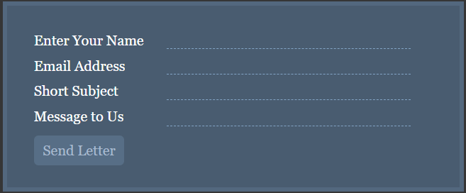

Code: (HTML)

<form class="form-style-4" action="" method="post">
<label for="field1">
<span>Enter Your Name</span><input type="text" name="field1" required="true" />
</label>
<label for="field2">
<span>Email Address</span><input type="email" name="field2" required="true" />
</label>
<label for="field3">
<span>Short Subject</span><input type="text" name="field3" required="true" />
</label>
<label for="field4">
<span>Message to Us</span><textarea name="field4" onkeyup="adjust_textarea(this)" required="true"></textarea>
</label>
<label>
<span> </span><input type="submit" value="Send Letter" />
</label>
</form>

- Lightbox Image Gallery

Cage lightbox image gallery is a group of images combined in one responsive gallery. Elements are grouped in thumbnail grid, which can be displayed as a slideshow.



Code: (HTML)

<div class="row">
<div class="column">
<img src="http://lorempixel.com/600/360/sports" style="width:100%" onclick="openModal();currentSlide(1)" class="hover-shadow cursor">
</div>
<div class="column">
<img src="http://lorempixel.com/600/360/food" style="width:100%" onclick="openModal();currentSlide(2)" class="hover-shadow cursor">
</div>
<div class="column">
<img src="http://lorempixel.com/600/360/animals" style="width:100%" onclick="openModal();currentSlide(3)" class="hover-shadow cursor">
</div>
<div class="column">
<img src="http://lorempixel.com/600/360/fashion" style="width:100%" onclick="openModal();currentSlide(4)" class="hover-shadow cursor">
</div>
</div>

<div id="myModal" class="modal">
<span class="close cursor" onclick="closeModal()">&times;</span>
<div class="modal-content">

<div class="mySlides">
<div class="numbertext">1 / 4</div>
<img src="http://lorempixel.com/600/360/sports" style="width:100%">
</div>

<div class="mySlides">
<div class="numbertext">2 / 4</div>
<img src="http://lorempixel.com/600/360/food" style="width:100%">
</div>

<div class="mySlides">
<div class="numbertext">3 / 4</div>
<img src="http://lorempixel.com/600/360/animals" style="width:100%">
</div>

<div class="mySlides">
<div class="numbertext">4 / 4</div>
<img src="http://lorempixel.com/600/360/fashion" style="width:100%">
</div>

<a class="prev" onclick="plusSlides(-1)">&#10094;</a>
<a class="next" onclick="plusSlides(1)">&#10095;</a>

<div class="caption-container">
<p id="caption"></p>
</div>

<div class="column">
<img class="demo cursor" src="http://lorempixel.com/600/360/sports" style="width:100%" onclick="currentSlide(1)" alt="Nature and sunrise">
</div>
<div class="column">
<img class="demo cursor" src="http://lorempixel.com/600/360/food" style="width:100%" onclick="currentSlide(2)" alt="Snow">
</div>
<div class="column">
<img class="demo cursor" src="http://lorempixel.com/600/360/animals" style="width:100%" onclick="currentSlide(3)" alt="Mountains and fjords">
</div>
<div class="column">
<img class="demo cursor" src="http://lorempixel.com/600/360/fashion" style="width:100%" onclick="currentSlide(4)" alt="Northern Lights">
</div>
</div>
</div>

<script src="script.js"></script>

</body>
</html>

- Loaders

Loaders (also known as preloaders) are simple animations that are used to keep visitors entertained while the page is still loading, which helps to increase the user experience.

Bootstrap “spinners” can be used to show the loading state in your projects. They’re built only with HTML and CSS, meaning you don’t need any JavaScript to create them.



Code: (HTML)

<div class="loader">
<svg viewBox="0 0 80 80">
<circle id="test" cx="40" cy="40" r="32"></circle>
</svg>
</div>

<div class="loader triangle">
<svg viewBox="0 0 86 80">
<polygon points="43 8 79 72 7 72"></polygon>
</svg>
</div>

<div class="loader">
<svg viewBox="0 0 80 80">
<rect x="8" y="8" width="64" height="64"></rect>
</svg>
</div>

- Navigation

Having easy-to-use navigation is important for any web site. With cage, you can transform boring HTML menus into good-looking navigation bars.

A navigation bar is basically a list of links, so using the <ul> and <li> elements makes perfect sense.

Code: (HTML)

<div class="nav">
<input type="checkbox" id="nav-check">
<div class="nav-header">
<div class="nav-title">
CAGE
</div>
</div>
<div class="nav-btn">
<label for="nav-check">
<span></span>
<span></span>
<span></span>
</label>
</div>

<div class="nav-links">
<a href="#">Home</a>
<a href="#">Code</a>
<a href="#">Documentation</a>
<a href="#">Examples</a>
<a href="#">About</a>
</div>
</div>

- Notification

Push notifications to your visitors with a toast, a lightweight and easily customizable alert message.

Toasts are lightweight notifications designed to mimic the push notifications that have been popularized by mobile and desktop operating systems.

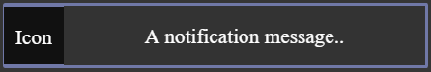

Code: (HTML)

<button onclick="launch_toast()" id="notif-btn">Show Toast</button>

<div id="toast"><div id="img">Icon</div><div id="desc">A notification message..</div></div>

<script src="script.js"></script>

- Pagination

Pagination is a component used to indicate existance of a series of related content across multiple pages and enables navigation across them.

We use a large block of connected links for our pagination, making links hard to miss and easily scalable—all while providing large hit areas.

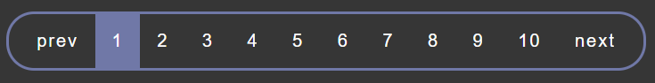

Code: (HTML)
<div class="pagination-wrapper">
<div class="pagination">
<a class="prev page-numbers" href="javascript:;">prev</a>
<span aria-current="page" class="page-numbers current">1</span>
<a class="page-numbers" href="javascript:;">2</a>
<a class="page-numbers" href="javascript:;">3</a>
<a class="page-numbers" href="javascript:;">4</a>
<a class="page-numbers" href="javascript:;">5</a>
<a class="page-numbers" href="javascript:;">6</a>
<a class="page-numbers" href="javascript:;">7</a>
<a class="page-numbers" href="javascript:;">8</a>
<a class="page-numbers" href="javascript:;">9</a>
<a class="page-numbers" href="javascript:;">10</a>
<a class="next page-numbers" href="javascript:;">next</a>
</div>
</div>

- Popovers

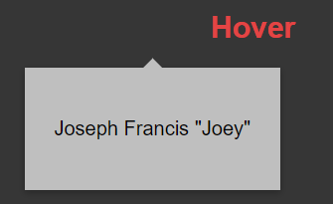

Code: (HTML)
<div class="popover__wrapper">
<a href="javascript:void(0)">
<h2 class="popover__title">Hover</h2>
</a>
<div class="popover__content">
<p class="popover__message">Joseph Francis "Joey"</p>
<!-- <img alt="Joseph Francis Joey Tribbiani, Jr." src="https://media.giphy.com/media/11SIBu3s72Co8w/giphy.gif"> -->
</div>
</div>

- Products Card

Product cards are a great way to organize listings of your products, services or just about any repetitive content. When well-designed, each individual card can stand out from the list and is easy to read. The use of additional effects like hover states and image filters can enhance things ever further.

Code: (HTML)
<div class="product-card">
<div class="badge">Hot</div>
<div class="product-tumb">
<img src="https://i.imgur.com/xdbHo4E.png" alt="">
</div>
<div class="product-details">
<span class="product-catagory">Women,bag</span>
<h4><a href="">Women leather bag</a></h4>
<p>Lorem ipsum dolor sit amet, consectetur adipisicing elit. Vero, possimus nostrum!</p>
<div class="product-bottom-details">
<div class="product-price"><small>Rs 96.00</small>230.99</div>
<div class="product-links">
<a href=""><i class="fa fa-heart"></i></a>
<a href=""><i class="fa fa-shopping-cart"></i></a>
</div>
</div>
</div>
</div>

- Progress Bar

Progress bar is a component which displays a progress of a process in which user is involved. Their color, shape, and animation can be customized.

A progress bar can be used to show how far along a user is in a process. Completely made up of CSS. This bar can also be used as a loader of the website.

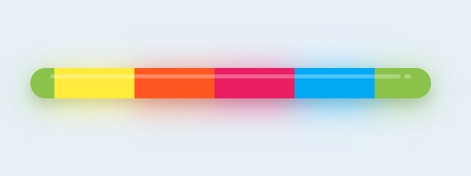
Code: (HTML)
<div class="wrapper">
<div class="progressbar">
<div class="stylization"></div>
</div>
</div>

- Radio Buttons

A radio button is a component used to allow a user to make a single choice among a number of options (whereas Checkboxes are used for selecting multiple options).

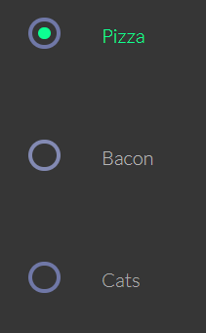

Code: (HTML)
<div class="container">

<ul>
<li>
<input type="radio" id="f-option" name="selector">
<label for="f-option">Pizza</label>

<div class="check"></div>
</li>

<li>
<input type="radio" id="s-option" name="selector">
<label for="s-option">Bacon</label>

<div class="check"><div class="inside"></div></div>
</li>

<li>
<input type="radio" id="t-option" name="selector">
<label for="t-option">Cats</label>

<div class="check"><div class="inside"></div></div>
</li>
</ul>
</div>

- Scrollbar

This element designs the default scrollbar of the website or the web browser to a new custom style and look. This way, the user can match the way the scrollbar looks in contrast to the looks of the website being designed.

Code: (HTML)

THERE IS NO NEED TO ADD ANY HTML CODE TO STYLE THE SCROLLBAR. YOU JUST NEED TO LINK THE CAGE CSS FRAMEWORK TO YOUR PAGE AND ITS ALL DONE. YOU ARE GOOD TO GO.

- Search bar

Search is a component which enables the user to find words, sentences, and numbers in a collection of documents, web pages or other sources.

It can be implemented with buttons or icons, then placed as an input or in a navbar for an even better user experience.

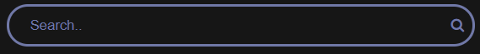

Code: (HTML)
<html>
<head>
<link rel="stylesheet" href="https://cdnjs.cloudflare.com/ajax/libs/font-awesome/4.7.0/css/font-awesome.min.css">
<link rel="stylesheet" href="style.css">
</head>
<body>

<div class="topnav">
<div class="search-container">
<form action="">
<input type="text" placeholder="Search.." name="search">
<button type="submit"><i class="fa fa-search"></i></button>
</form>
</div>
</div>

</body> </html>
- Smooth Scroll

Smooth scroll is an animated movement from a trigger - button, link or any other clickable element - to another place of the same page.

<div class="main" id="section1">
<h2>Section 1</h2>
<a href="#section2">Click Me to Smooth Scroll to Section 2 Below</a>
</div>

<div class="main" id="section2">
<h2>Section 2</h2>
<a href="#section1">Click Me to Smooth Scroll to Section 1 Above</a>
</div>

- Social Icons

Social buttons are buttons which are dedicated to social media usage. Font Awesome covers icons for all major platforms.

Hard to imagine a good website or app without integration with Social Media.

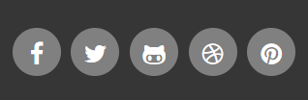

Code: (HTML)
<head>
<meta charset="UTF-8">
<title>Social Icons</title>
<link rel="stylesheet" href="https://maxcdn.bootstrapcdn.com/font-awesome/4.5.0/css/font-awesome.min.css">
<link rel="stylesheet" href="style.css"/>
</head>
<body>
<div>
<a href="http://www.facebook.com" class="icon facebook"><span>Facebook</span></a>
<a href="http://www.twitter.com" class="icon twitter"><span>Twitter</span></a>
<a href="http://www.github.com" class="icon github"><span>Github</span></a>
<a href="http://www.dribble.com" class="icon dribble"><span>Dribble</span></a>
<a href="http://pinterest.com" class="icon pinterest"><span>Pinterest</span></a>
</div>
</body>
</html>

- Sticky Content

Sticky content (affix) is a plugin which allows elements to be locked in the particular area of the page. Often used in navigation menus.
Sticky content is fixed to the specific area of the page no matter where the page is moving or scrolling.
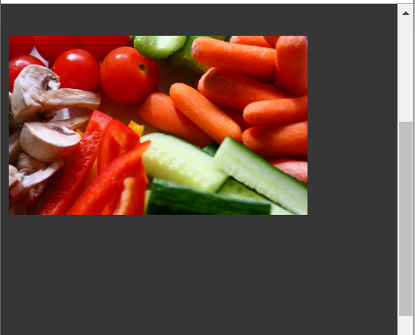
Code: (HTML)
<body>
<div class="item police">
<img src="http://lorempixel.com/600/360/food" width="300" alt="Item">
</div>
</body>

- Tabs

Tabs are components which separate content placed in the same wrapper, but in the separate pane. Only one pane can be displayed at the time.

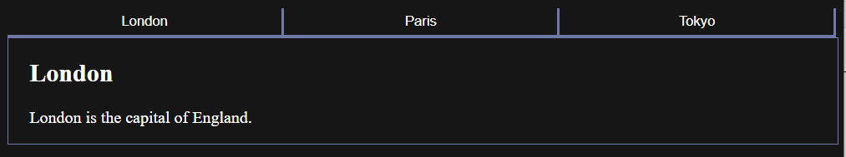

Code: (HTML)

<div class="item police">
<img src="http://lorempixel.com/600/360/food" width="300" alt="Item">
</div>

- Content Accordion

This element works like an accordion but instead of listing horizontally and showing expanded images and data, it is aligned vertically and shows the expanded content vertically as an accordion.

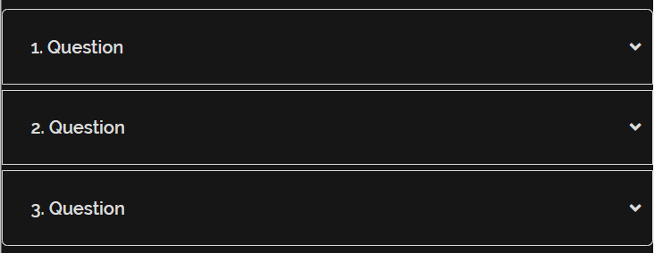

Code: (HTML)
<div class="accordion mt-3">

<div class="accordion-content">
<input type="checkbox" name="que" class="accord" id="question-1">
<label for="question-1" id="acc-first">1. Question</label>
<section class="collapse">
<p>
Lorem ipsum dolor sit amet consectetur adipisicing elit. Alias, nobis maxime, nesciunt provident dignissimos omnis voluptate ratione, vel in deserunt eius temporibus. Est qui vero culpa consequatur possimus quia minus.Temporibus, culpa cum at perspiciatis pariatur dolorum iste numquam rem beatae reprehenderit libero nobis laborum! A officiis necessitatibus magnam vero, qui earum animi sit, veniam quasi, inventore quae illo odio.
</p>
</section>
</div>

<div class="accordion-content">
<input type="checkbox" name="que" class="accord" id="question-2">
<label for="question-2">2. Question</label>
<section class="acc-collapse">
<p>
Lorem ipsum dolor sit amet consectetur adipisicing elit. Alias, nobis maxime, nesciunt provident dignissimos omnis voluptate ratione, vel in deserunt eius temporibus. Est qui vero culpa consequatur possimus quia minus.Temporibus, culpa cum at perspiciatis pariatur dolorum iste numquam rem beatae reprehenderit libero nobis laborum! A officiis necessitatibus magnam vero, qui earum animi sit, veniam quasi, inventore quae illo odio.
</p>
</section>
</div>

<div class="accordion-content">
<input type="checkbox" name="que" class="accord" id="question-3">
<label for="question-3" id="acc-last">3. Question</label>
<section class="collapse">
<p>
Lorem ipsum dolor sit amet consectetur adipisicing elit. Alias, nobis maxime, nesciunt provident dignissimos omnis voluptate ratione, vel in deserunt eius temporibus. Est qui vero culpa consequatur possimus quia minus.Temporibus, culpa cum at perspiciatis pariatur dolorum iste numquam rem beatae reprehenderit libero nobis laborum! A officiis necessitatibus magnam vero, qui earum animi sit, veniam quasi, inventore quae illo odio.
</p>
</section>
</div>

</div>

ALSO THE CAGE CSS FRAMEWORK IS ALSO CONVERTED INTO ITS MINIFIED VERSION TOO SO THAT IT BECOMES EVEN LIGHTER THAN IT IS SUPPOSED TO BE WITHOUT BEING MINIFIED.

The Cage Framework CSS file can be either downloaded offline and linked and also it can be used with the help of the CDN network link provided.

Cage CSS Grid

The CSS Grid Layout Module offers a grid-based layout system, with rows and columns, making it easier to design web pages without having to use floats and positioning.

CSS Grid is a powerful tool that allows for two-dimensional layouts to be created on the web.
It excels at dividing a page into major regions or defining the relationship in terms of size, position, and layer, between parts of a control built from HTML primitives.

Like tables, grid layout enables an author to align elements into columns and rows. However, many more layouts are either possible or easier with CSS grid than they were with tables.
For example, a grid container's child elements could position themselves so they actually overlap and layer, similar to CSS positioned elements.

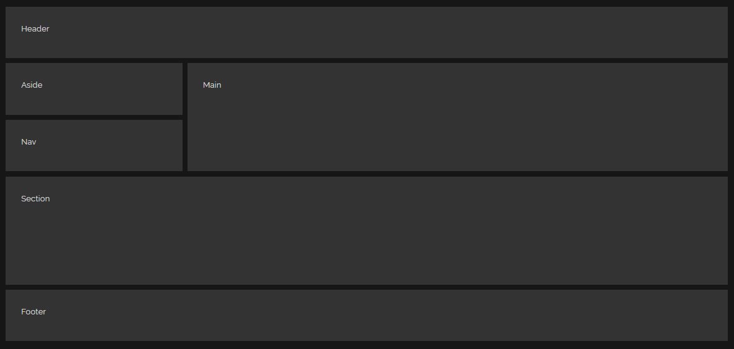

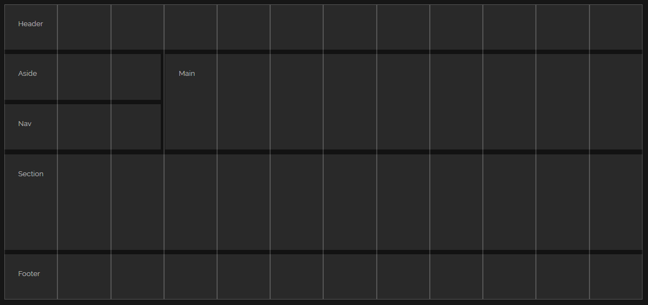

Table Grid

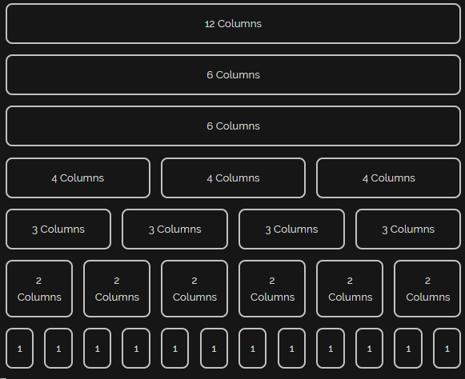
<!-- CSS GRID -->

<input type="checkbox">
<div id="content-1">

<div id="grid">
<p></p>
<p></p>
<p></p>
<p></p>
<p></p>
<p></p>
<p></p>
<p></p>
<p></p>
<p></p>
<p></p>
<p></p>
</div>

<header class="cg-1-head">Header</header>
<main class="cg-1-main">Main</main>
<section class="cg-1-sect">Section</section>
<aside class="cg-1-aside">Aside</aside>
<nav class="cg-1-nav">Nav</nav>
<footer class="cg-1-foot">Footer</footer>

</div>
<!-- CSS GRID END -->
<!-- Table Grid -->

<div class="grid">
<div class="row">

<div class="col-wd-12">
<div class="col">12 Columns</div>
</div>

<div class="col-wd-6">
<div class="col">6 Columns</div>
</div>
<div class="col-wd-6">
<div class="col">6 Columns</div>
</div>

<div class="col-wd-6 col-md-4">
<div class="col">4 Columns</div>
</div>
<div class="col-wd-6 col-md-4">
<div class="col">4 Columns</div>
</div>
<div class="col-wd-12 col-md-4">
<div class="col">4 Columns</div>
</div>

<div class="col-wd-6 col-md-3">
<div class="col">3 Columns</div>
</div>
<div class="col-wd-6 col-md-3">
<div class="col">3 Columns</div>
</div>
<div class="col-wd-6 col-md-3">
<div class="col">3 Columns</div>
</div>
<div class="col-wd-6 col-md-3">
<div class="col">3 Columns</div>
</div>

<div class="col-wd-6 col-md-4 col-sm-2">
<div class="col">2 Columns</div>
</div>
<div class="col-wd-6 col-md-4 col-sm-2">
<div class="col">2 Columns</div>
</div>
<div class="col-wd-6 col-md-4 col-sm-2">
<div class="col">2 Columns</div>
</div>
<div class="col-wd-6 col-md-4 col-sm-2">
<div class="col">2 Columns</div>
</div>
<div class="col-wd-6 col-md-4 col-sm-2">
<div class="col">2 Columns</div>
</div>
<div class="col-wd-6 col-md-4 col-sm-2">
<div class="col">2 Columns</div>
</div>

<div class="col-wd-3 col-md-2 col-sm-1">
<div class="col">1</div>
</div>
<div class="col-wd-3 col-md-2 col-sm-1">
<div class="col">1</div>
</div>
<div class="col-wd-3 col-md-2 col-sm-1">
<div class="col">1</div>
</div>
<div class="col-wd-3 col-md-2 col-sm-1">
<div class="col">1</div>
</div>
<div class="col-wd-3 col-md-2 col-sm-1">
<div class="col">1</div>
</div>
<div class="col-wd-3 col-md-2 col-sm-1">
<div class="col">1</div>
</div>
<div class="col-wd-3 col-md-2 col-sm-1">
<div class="col">1</div>
</div>
<div class="col-wd-3 col-md-2 col-sm-1">
<div class="col">1</div>
</div>
<div class="col-wd-3 col-md-2 col-sm-1">
<div class="col">1</div>
</div>
<div class="col-wd-3 col-md-2 col-sm-1">
<div class="col">1</div>
</div>
<div class="col-wd-3 col-md-2 col-sm-1">
<div class="col">1</div>
</div>
<div class="col-wd-3 col-md-2 col-sm-1">
<div class="col">1</div>
</div>

</div>
</div>

<!-- Table Grid End -->

TOOLS USED

- HTML

Hypertext Markup Language (HTML) is the standard markup language for creating web pages and web applications. With Cascading Style Sheets (CSS) and JavaScript, it forms a triad of cornerstone technologies for the World Wide Web.

Web browsers receive HTML documents from a web server or from local storage and render the documents into multimedia web pages. HTML describes the structure of a web page semantically and originally included cues for the appearance of the document.

HTML elements are the building blocks of HTML pages. With HTML constructs, images and other objects such as interactive forms may be embedded into the rendered page. HTML provides a means to create structured documents by denoting structural semantics for text such as headings, paragraphs, lists, links, quotes and other items. HTML elements are delineated by tags, written using angle brackets.



- CSS

Cascading Style Sheets (CSS) is a style sheet language used for describing the presentation of a document written in a markup language like HTML. CSS is a cornerstone technology of the World Wide Web, alongside HTML and JavaScript.

CSS is designed to enable the separation of presentation and content, including layout, colors, and fonts. This separation can improve content accessibility, provide more flexibility and control in the specification of presentation characteristics, enable multiple web pages to share formatting by specifying the relevant CSS in a separate .css file, and reduce complexity and repetition in the structural content.

Separation of formatting and content also makes it feasible to present the same markup page in different styles for different rendering methods, such as on-screen, in print, by voice (via speech-based browser or screen reader), and on Braille-based tactile devices. CSS also has rules for alternate formatting if the content is accessed on a mobile device.

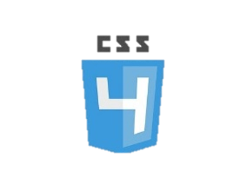
- SASS

CSS on its own can be fun, but stylesheets are getting larger, more complex, and harder to maintain. This is where a preprocessor can help. Sass lets you use features that don't exist in CSS yet like variables, nesting, mixins, inheritance and other nifty goodies that make writing CSS fun again.

Once you start tinkering with Sass, it will take your preprocessed Sass file and save it as a normal CSS file that you can use in your website.

The most direct way to make this happen is in your terminal. Once Sass is installed, you can compile your Sass to CSS using the sass command. You'll need to tell Sass which file to build from, and where to output CSS to. For example, running sass input.scss output.css from your terminal would take a single Sass file, input.scss, and compile that file to output.css.


- JAVASCRIPT

JavaScript often abbreviated as JS, is a high-level, interpreted programming language that conforms to the ECMAScript specification. JavaScript has curly-bracket syntax, dynamic typing, prototype-based object-orientation, and first-class functions.

As a multi-paradigm language, JavaScript supports event-driven, functional, and imperative (including object-oriented and prototype-based) programming styles. It has APIs for working with text, arrays, dates, regular expressions, and the DOM, but the language itself does not include any I/O, such as networking, storage, or graphics facilities. It relies upon the host environment in which it is embedded to provide these features.

Initially only implemented client-side in web browsers, JavaScript engines are now embedded in many other types of host software, including server-side in web servers and databases, and in non-web programs such as word processors and PDF software, and in runtime environments that make JavaScript available for writing mobile and desktop applications, including desktop widgets.



- VISUAL STUDIO CODE and Atom Code Editor

Visual Studio Code and Atom are highly functional and operations enriched text editors that comes with a whole ton of functionalities that makes it easy to manage and edit the code files of any type of text file.
The functionalities of Visual Studio code editor has helped this project for the process of Sass compilation and Execution and management.

- Google Chrome

Google Chrome is used as the web browser to implement, execute and monitor the changes and result of the generated css framework.

- Adobe XD

Adobe XD is a vector-based tool developed and published by Adobe Inc for designing and prototyping user experience for web and mobile apps. The software is available for macOS, Windows, iOS and Android.

We used the Adobe XD to create a design of the desired components and elements as required before staring with the actual coding and designing.

HOW ARE WE GOING TO ACHIEVE THE RESULT

- To achieve our end result we’re using SASS which is an extension of CSS
- SASS with its ‘mixin’ and ‘import’ property make the workflow easy.
- Through this we can create different modules for every element.
- The first file will be Normalize.css which resets the setting of default web browser css.
- And the next will be Cage.css which will be created through the modules.

HOMEPAGE / LANDING PAGE

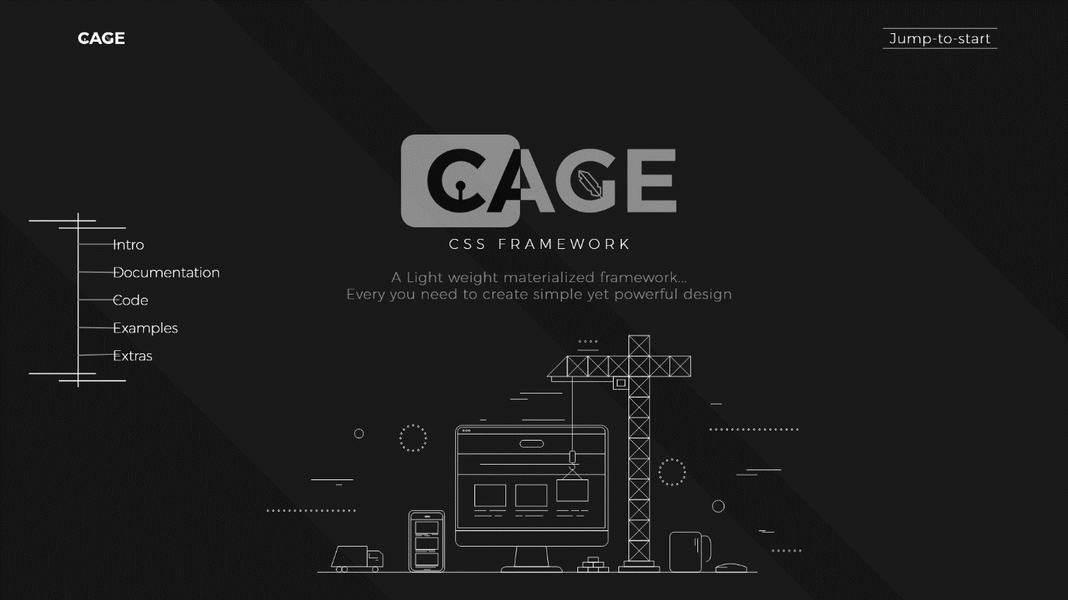

INTRO

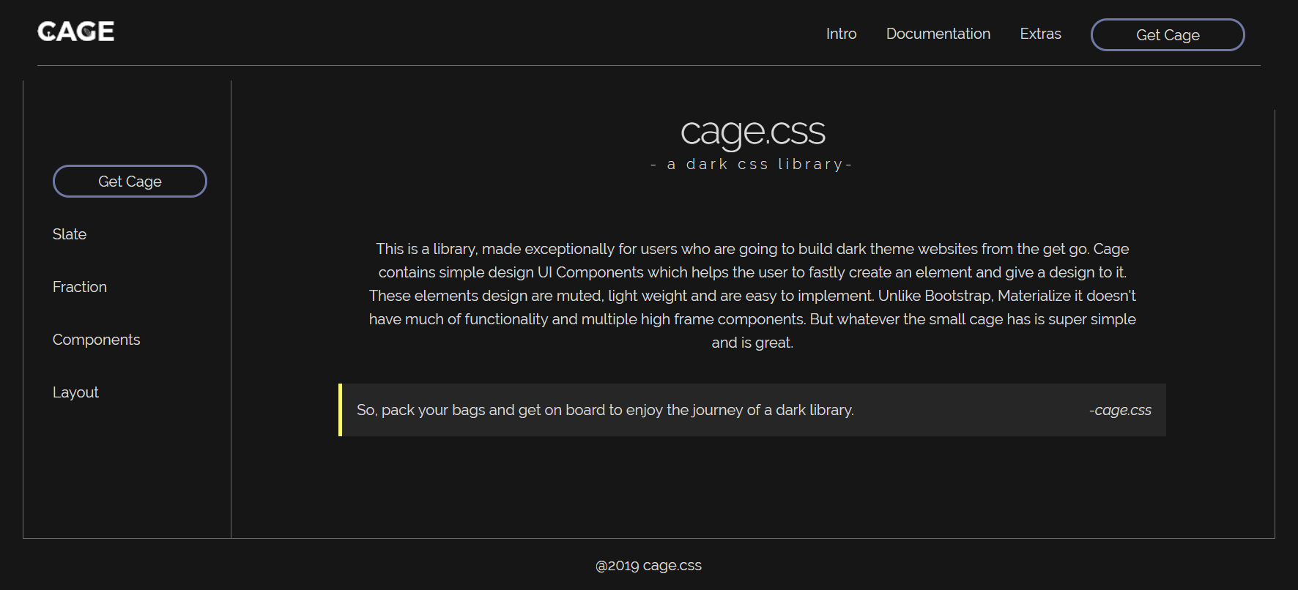

Fractions

Fractions are the CSS Sass elements which are generated in order to to divide a page into different fractions of necessary designs which are as follows:

- _align.scss
- _space.scss
- _visibility.scss

These three basic properties are defined into the fractions section of the sass component.
The codes written in these files are supposed to overwrite the default formatting and styling of the web page or web browser for that website.
The properties which are affected to generate custom designs are – Alignment, Spacing, and Visibility.

//Allingment classes

.base-align{
vertical-align: baseline !important;
}

.top-align{
vertical-align: top !important;
}

.mid-align{
vertical-align: middle !important;
}

.btm-align{
vertical-align: bottom !important;
}

.text-btm-align{
vertical-align: text-bottom !important;
}

.text-top-align{
vertical-align: text-top !important;
}

//text align
.text-center{
text-align: center !important;
}

.text-left{
text-align: center !important;
}

.text-right{
text-align: center !important;
}

//End of alignment

.w-25 {
width: 25% !important;
}

.w-50 {
width: 50% !important;
}

.w-75 {
width: 75% !important;
}

.w-100 {
width: 100% !important;
}

.w-auto {
width: auto !important;
}

.h-25 {
height: 25% !important;
}

.h-50 {
height: 50% !important;
}

.h-75 {
height: 75% !important;
}

.h-100 {
height: 100% !important;
}

.h-auto {
height: auto !important;
}

.mw-100 {
max-width: 100% !important;
}

.mh-100 {
max-height: 100% !important;
}

.m-0 {
margin: 0 !important;
}

.mt-0,
.my-0 {
margin-top: 0 !important;
}

.mr-0,
.mx-0 {
margin-right: 0 !important;
}

.mb-0,
.my-0 {
margin-bottom: 0 !important;
}

.ml-0,
.mx-0 {
margin-left: 0 !important;
}

.m-1 {
margin: 0.25rem !important;
}

.mt-1,
.my-1 {
margin-top: 0.25rem !important;
}

.mr-1,
.mx-1 {
margin-right: 0.25rem !important;
}

.mb-1,
.my-1 {
margin-bottom: 0.25rem !important;
}

.ml-1,
.mx-1 {
margin-left: 0.25rem !important;
}

.m-2 {
margin: 0.5rem !important;
}

.mt-2,
.my-2 {
margin-top: 0.5rem !important;
}

.mr-2,
.mx-2 {
margin-right: 0.5rem !important;
}

.mb-2,
.my-2 {
margin-bottom: 0.5rem !important;
}

.ml-2,
.mx-2 {
margin-left: 0.5rem !important;
}

.m-3 {
margin: 1rem !important;
}

.mt-3,
.my-3 {
margin-top: 1rem !important;
}

.mr-3,
.mx-3 {
margin-right: 1rem !important;
}

.mb-3,
.my-3 {
margin-bottom: 1rem !important;
}

.ml-3,
.mx-3 {
margin-left: 1rem !important;
}

.m-4 {
margin: 1.5rem !important;
}

.mt-4,
.my-4 {
margin-top: 1.5rem !important;
}

.mr-4,
.mx-4 {
margin-right: 1.5rem !important;
}

.mb-4,
.my-4 {
margin-bottom: 1.5rem !important;
}

.ml-4,
.mx-4 {
margin-left: 1.5rem !important;
}

.m-5 {
margin: 3rem !important;
}

.mt-5,
.my-5 {
margin-top: 3rem !important;
}

.mr-5,
.mx-5 {
margin-right: 3rem !important;
}

.mb-5,
.my-5 {
margin-bottom: 3rem !important;
}

.ml-5,
.mx-5 {
margin-left: 3rem !important;
}

.p-0 {
padding: 0 !important;
}

.pt-0,
.py-0 {
padding-top: 0 !important;
}

.pr-0,
.px-0 {
padding-right: 0 !important;
}

.pb-0,
.py-0 {
padding-bottom: 0 !important;
}

.pl-0,
.px-0 {
padding-left: 0 !important;
}

.p-1 {
padding: 0.25rem !important;
}

.pt-1,
.py-1 {
padding-top: 0.25rem !important;
}

.pr-1,
.px-1 {
padding-right: 0.25rem !important;
}

.pb-1,
.py-1 {
padding-bottom: 0.25rem !important;
}

.pl-1,
.px-1 {
padding-left: 0.25rem !important;
}

.p-2 {
padding: 0.5rem !important;
}

.pt-2,
.py-2 {
padding-top: 0.5rem !important;
}

.pr-2,
.px-2 {
padding-right: 0.5rem !important;
}

.pb-2,
.py-2 {
padding-bottom: 0.5rem !important;
}

.pl-2,
.px-2 {
padding-left: 0.5rem !important;
}

.p-3 {
padding: 1rem !important;
}

.pt-3,
.py-3 {
padding-top: 1rem !important;
}

.pr-3,
.px-3 {
padding-right: 1rem !important;
}

.pb-3,
.py-3 {
padding-bottom: 1rem !important;
}

.pl-3,
.px-3 {
padding-left: 1rem !important;
}

.p-4 {
padding: 1.5rem !important;
}

.pt-4,
.py-4 {
padding-top: 1.5rem !important;
}

.pr-4,
.px-4 {
padding-right: 1.5rem !important;
}

.pb-4,
.py-4 {
padding-bottom: 1.5rem !important;
}

.pl-4,
.px-4 {
padding-left: 1.5rem !important;
}

.p-5 {
padding: 3rem !important;
}

.pt-5,
.py-5 {
padding-top: 3rem !important;
}

.pr-5,
.px-5 {
padding-right: 3rem !important;
}

.pb-5,
.py-5 {
padding-bottom: 3rem !important;
}

.pl-5,
.px-5 {
padding-left: 3rem !important;
}

.m-auto {
margin: auto !important;
}

.mt-auto,
.my-auto {
margin-top: auto !important;
}

.mr-auto,
.mx-auto {
margin-right: auto !important;
}

.mb-auto,
.my-auto {
margin-bottom: auto !important;
}

.ml-auto,
.mx-auto {
margin-left: auto !important;
}

// Visibility

.visible{
visibility: visible !important;
}

.hidden{
visibility: hidden !important;
}

Mixin Functions

They are used to provide dynamic functionalities to the design by using maps.

Maps are created with the help of Sass variables in which we store the required variables inside one variable and set it as the default.

We have created different Mixin functions in order to provide dynamic functionality and styling to the following elements:

- _alert.scss
- _breakpoint.scss
- _button.scss
- _cards.scss
- _checkbox.scss …. And more..

- Breakpoints

In the mixin of breakpoints, we first set the maps to the variables at which we want the screen to break. Following are the points:

//Breakpoint Map

$breakpoints: (
'small' : 33.75rem, //540px
'med' : 47.5rem, //760px
'large' : 62rem, //992px
'wide' : 75rem //1200px
) !default;

With the help of these points, we create a map know as breakpoints which helps us to break the design according to the screen size.

Now, to access these points inside other scss files, to make the code responsive, we have created the below function:

//Mixin to manage responsive breakpoints

@mixin respond-to($breakpoint){

//If map has key then
@if map-has-key($breakpoints, $breakpoint ){

//Prints media query
@media (max-width: map-get($breakpoints, $breakpoint)) {
@content;
}

}

//If doesn't
@else{
@warn "No value retrieved at `#{$breakpoint}`."
+ "Only breakpoints are `#{map-key($breakpoints)}`"
}

}

To use the above function with an element, we use @include statement.

@include respond-to(‘$breakpoint-name’){

// Content at the given breakpoint
}

Alert, Button, Cards, Checkbox etc..

- These mixins are used only to dynamically change the color schemes of the components.
- Here we have used color map.

//Color Schemes

$white: #ffffff !default; //default prop is specific to sass which means giving default value to a variable
$gray-1: #dbdbdb !default;
$gray-2: #c2c2c2 !default;
$gray-3: #a5a5a5 !default;
$gray-4: #6d6d6d !default;
$gray-5: #363636 !default;
$black: #000000 !default;

$theme-bg: #161616 !default;

$blue: #1a7ae0 !default;
$fade-blue: #7078a7 !default;
$purple: #b66ddb !default;
$pink: #e45095 !default;
$red: #e25252 !default;
$orange: #ff8c2d !default;
$yellow: #fafa74 !default;
$green: #82Cf6d !default;
$paraket: #27c596 !default;
$turqoise: #1a9aad !default;

$colors: () !default;
$colors: map-merge((
"blue": $blue,
"fade-blue": $fade-blue,
"purple": $purple,
"pink": $pink,
"red": $red,
"orange": $orange,
"green": $green,
"paraket": $paraket,
"turqoise": $turqoise
), $colors);

//Theme based color
$primary: $fade-blue !default;
$secondary: $paraket !default;
$success: $green !default;
$waiting: $yellow !default;
$info: $paraket !default;
$peace: $purple !default;
$light: $gray-1 !default;
$dark: $gray-5 !default;

$theme-colors: () !default;
$theme-colors: map-merge((
"primary": $primary,
"secondary": $secondary,
"success": $success,
"waiting": $waiting,
"info": $info,
"peace": $peace,
"light": $light,
"dark": $dark
) , $theme-colors );

With the help of above map, we create a function to dynamically change the color scheme of the elements by just giving the class name of the color we want to apply to the element.

//Mixin for buttons

@mixin button-border($border){

border: 2px solid $border;
border-radius: 1000px;
color: $gray-1;

&:hover{
background: darken($border,10%);
border-color: darken($border,10%);
transition: all 0.3s ease;
color: $gray-1;
}

}

//Gradiant hover
@mixin button-g-border($border){

border: 2px solid $border;
border-radius: 1000px;
color: $dark;

&:hover{
background: linear-gradient( transparent 0%, transparent 32%, $border 32%, $border 100%);

transition: all 0.3s ease;
color: $white;
}

}

Slate.scss

Slate.scss is the first and an important part of cage.
What slate do is that it changes the actual default styling of the browser to the cage custom default styles.

In simple terms, It resets the browsers default style to its own.

Also, we have used our own custom font sizes for the html tags which we have defined in the _font-var.scss file.

body{
font-size: 16px;
}

// Font size variables

$font-h1: 2.7rem;
$font-h2: 2.3rem;
$font-h3: 2rem;
$font-h4: 1.6rem;
$font-h5: 1.4rem;
$font-h6: 1rem;
$font-p: 0.9rem;

//Line height
$line-height-h1: 1;
$line-height-h2: 1.05;
$line-height-h3: 1.1;
$line-height-h4: 1.15;
$line-height-h5: 1.3;
$line-height-h6: 1.4;

//Font weight
$font-300: 300;
$font-300i: 300i;
$font-400: 400;
$font-400i: 400i;
$font-500: 500;
$font-500i: 500i;
$font-600: 600;
$font-600i: 600i;
$font-700: 700;
$font-700i: 700i;

//Button font
$btn-font: 1rem;

//alert font
$alert-font: 1rem;

//card font
$card-font: 1rem;

//drop font
$drop-font: 1rem;

In this we have used rem units instead of pixels to provide a better control over sizing and each rem equals to 16px.

How to use Cage?

To implement Cage features in one’s project, the user first has to link certain file to their html document.
-The first is cage.css file, the user can use cage.min.css which is its minified version with less size.
-The second is cage.js file.
With the linking of above two files, you’re good to go.

Now to use it-
- After completing the above process, the user’s project is already using cage, with its default mark i.e., with just linking the files the default styling of the html document is changed to cage default styling.

- The whole font styling base is set to 16px – Raleway(A free google font). Also, based on the 16px we’re using rems to make the adjustments more dynamic(1rem=16px).

- This whole library is designed for dark themed websites, as the current trend follows dark theme websites.

- All the elements in this library are based on a color-theme.

Color scheme  - $blue: #1a7ae0 !default;  - $fade-blue: #7078a7 !default;  - $purple: #b66ddb !default;  - $pink: #e45095 !default;  - $red: #e25252 !default;  - $orange: #ff8c2d !default;  - $yellow: #fafa74 !default;  - $green: #82Cf6d !default;  - $paraket: #27c596 !default;  - $turqoise: #1a9aad !default; | Transferred to theme  - $primary: $fade-blue !default;  - $secondary: $paraket !default;  - $success: $green !default;  - $waiting: $yellow !default;  - $info: $paraket !default;  - $peace: $purple !default;  - $light: $gray-1 !default;  - $dark: $gray-5 !default;

- Next is to implement design: to do so, the user has to do the simplest thing i.e., to provide classes and ids to the element henceforth leading to the desired styling.

Examples:
- Buttons: Based on the above theme base color-scheme we can style out button.

  - This is a button tag.
<button>Button</button>
  - By adding two simple classes to it we can change the design of the button
<button class=”btn primary-btn”>Primary</button>
With this we get a button with the primary color border given to it. Below is the design.

Similarly, by changing class from ‘primary-btn’ to ‘peace-btn’ will give a result like this.

--To use these class and get to know them you can use the cage website documentation page which will help you in creating the element with the desired styling.

Conclusion: Cage

Cage.css is the final file which consists of all the styling which we have created using SASS, and then compiled into css.

To use these styles, the user just has to link cage.css file to the html document or they can use the minified version of cage.css i.e, cage.min.css

With all the sass modules, the end combined result we get is cage library.

With the usage of sass, we achieved less coding with efficient output….

References

- css-tricks.com
- stackoverflow.com
- google.com
- w3school.com
- reference using skeleton.css
- caniuse.com
- codepen.io
- freecodecamp.com

